**Practice Sheet: Unit 3 and Unit 4**

**Q1:**

**Information:** Smoking and bad diet are regarded as causes of heart disease. The heart disease in turn is a cause of high blood pressure and an abnormal electrocardiogram.

**Bayesian Network:**

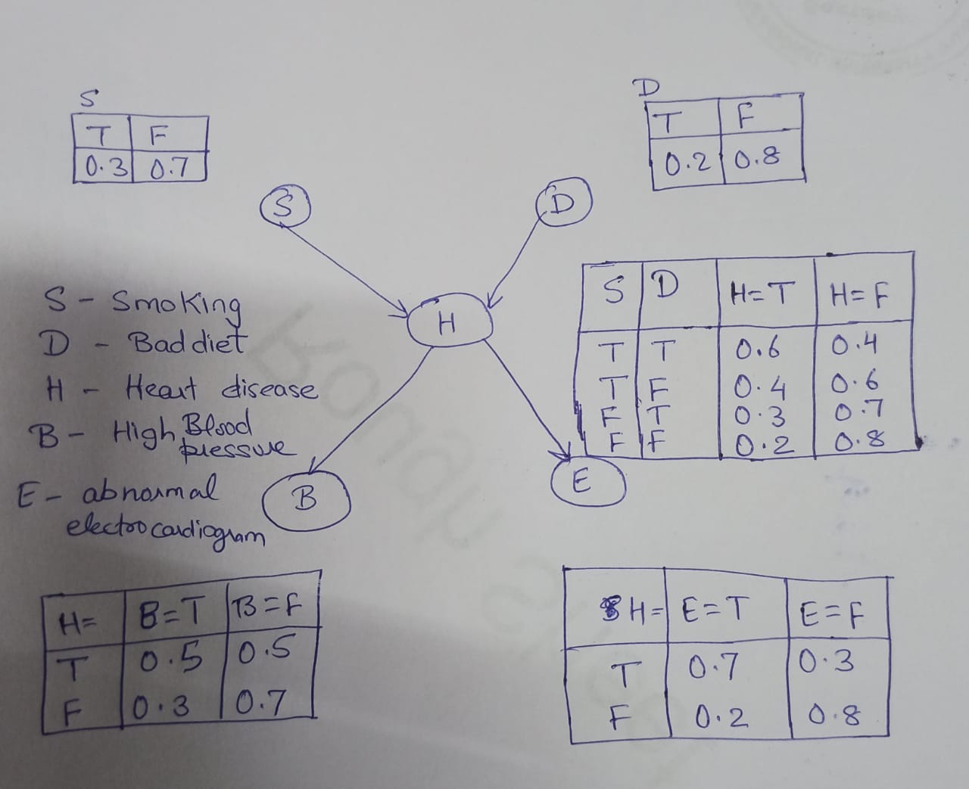

1. Find the probability that person is having a problem of high blood pressure given that he is not having any heart disease. The person does not smoke but having a problem of bad diet.
2. Find the probability that person is having a problem of abnormal electrocardiogram given that he is also suffering having any heart disease. The person having good diet but has habit of smoking.

**Q2.** A crime had happened in the city in the presence of 100 people. Govt. make two investigation team. Team 1 interrogated 50 people present on crime site. 30 of them said that criminal came in black car where as 20 people said that car was either of black or brown car. Team 2 also interrogated randomly selected 50 people. 20 of them said car is of brown colour where as 30 people said that car is of either black or blue colour. Combine the interrogation results of both investigation team using Dempster Shafer theory for final decision.

**Q3.** A robot had to be sent to Mars some that robot is tested in lab. Robot may have problem either with leg or arm. These problem can produce three kind of error: type1, type 2, type 3. After doing the test in the lab following result are obtained:

Probability that the robot has problem in leg is 0.4 and the probability the robot has problem in arm is 0.5.

Probability of type 1 error when problem is with leg =0.2

Probability of type 2 error when problem is with leg = 0.3

Probability of type 3 error when problem is with leg = 0.3

Probability of type 1 error when problem is with arm = 0.2

Probability of type 2 error when problem is with arm =0.2

Probability of type 3 error when problem is with arm =0.4

After reaching at Mars robot face start getting type 3 error, what is the probability that error is because of problem in arm.

**Q4.** What is resolution in AI and what are the steps of performing resolution to check validity of goal statement?

**Q5.** What are four properties of a good knowledge presentation?

**Q6.** Explain the simple relational knowledge presentation and inheritable knowledge presentation with examples?

**Q7.** Explain the inferential knowledge presentation with an example? What are its advantages?

**Q8.** Explain the procedural knowledge presentation?

**Q9.** What are the different issues that has to be considered in knowledge presentation?

**Q10** Explain the different logical connectives with examples, available in propositional knowledge presentation?

**Q11.** Explain the steps to find whether Marcus is alive or not using predicate knowledge presentation from given facts:

1. Marcus was a man.
2. Marcus was a Pompeian.
3. Marcus was born in 40 A.D.
4. All men are mortal.
5. All Pompeians died when the volcano erupted in 79 A.D.
6. No mortal lives longer than 150 years.
7. It is now 1991.
8. Alive means not dead.
9. If someone dies, then he is dead at all later times.

**Q12:** What is clause form and what are the steps to converts given facts into clause form and conjunctive normal form?

**Q13**: Given facts:

1. All people who are graduating are happy.
2. All happy people smile
3. Someone is graduating

Check the fact that is someone is smiling **using resolution method?**

**Q14.** Consider the following Knowledge Base:

1. The humidity is high or the sky is cloudy.
2. If the sky is cloudy, then it will rain.
3. If the humidity is high, then it is hot.
4. It is not hot.

Check whether it will rain or not **using resolution method?**

**Q15.** There are some fact/ axioms P, Q, R, S, T having following four relations:

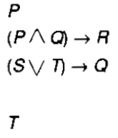

Check ”R” is true or not using resolution method?

**Q16.** What are the different rules used for combing evidences in certainty factor theory?

**Q17.** P, Q, R are the three different literals/ axioms in propositional logic. Write truth table for the relation $Q∧R→¬P$.